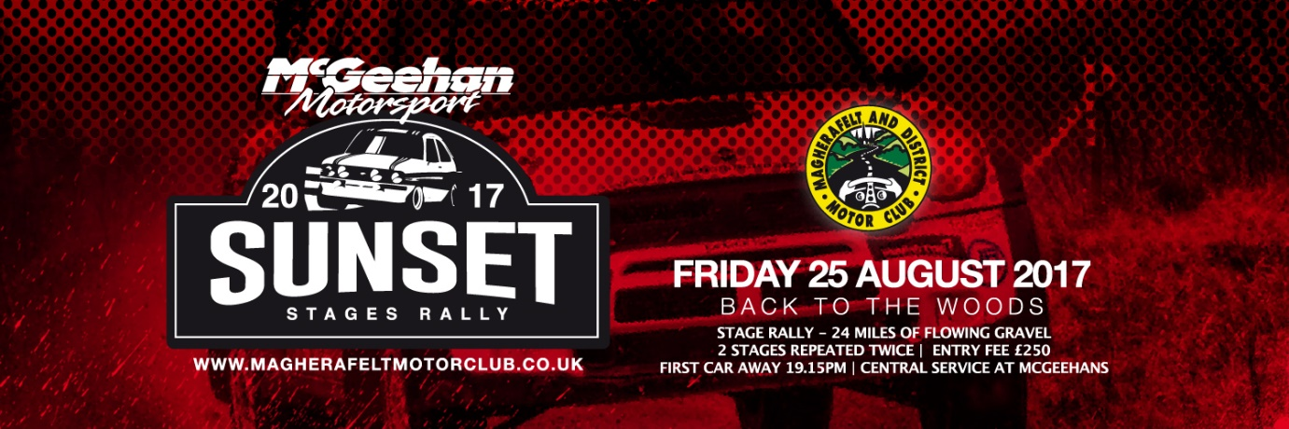

MC GEEHAN MOTORSPORT SUNSET STAGES RALLY IS LAUNCHED IN DRAPERSTOWN

Magherafelt and District Motor Club members attended the launch of the Mc Geehan Motorsport Sunset Stages Rally which is being held on the evening of Friday 25th August. There will be approximately 24 competitive miles on a mixed/gravel surface and indeed some closed roads. The event will use two local forests Davagh and Banagher in what promises to be a thrilling event. Following mechanical scrutiny and signing on at Mc Geehan Motorsport Yard, cars will drive out to the forest to complete two stages which will be repeated. The Sunset Stages Rally can accommodate up to 80 competitors and this event always proves popular with competitors who enjoy the added thrill of racing in the dark.
Clerk of the Course Stephen O’Neill thanked Derek Mc Geehan of McGeehan Motorsport for sponsoring the event stating that without this generous sponsorship it would not be possible to run such a prestigious rally. Stephen said planning is well underway and the working group have ensured a safe but exciting event for all competitors. He thanked the Stage Commanders Willie Wylie and Michael Irvine for their commitment in getting the manpower to run the stages successfully. He added his thanks to all the Magherafelt Motorclub members who had been out in the forests ensuring that the surfaces are in good rally condition. Stephen O’Neill added that although entries had just been opened; five had already been received; which was a good sign in these economic times. Stephen concluded that the support both physical and financial of Mc Geehan Motorsport was essential to the running of the rally and thanked them for their generosity.
Derek Mc Geehan of Mc Geehan Motorpsort expressed his delight at sponsoring the event, saying that he had been a member of Magherafelt and District Motorclub for over 25 years and loved the Sunset Rally which he viewed as his home event. Derek added that as a businessman, he was always at rallies working on competitors’ cars; so he was not free to marshal or assist in the running of events; therefore he believed that providing financial sponsorship and the Mc Geehan Motorsport Yard as a venue was his way of giving back to the motorsport community.
In Draperstown Derek Mc Geehan is known as the local rally man and he is proud of the fact that he is bringing business to this area of South Derry. Derek stated that he hoped the event would be well supported by competitors from all over Ireland and the U.K. and that Draperstown businesses would profit as a result.
Another aspect of basing the Mc Geehan Stages Rally in Draperstown that is important to Derek McGeehan is the fact that families and children can come into the service area and see world rally cars up close. There will be a wide range of cars competing from Mark 2 Escorts to WRCs. Derek Mc Geehan feels that if young people see these fast cars in a controlled and safe environment it will promote the road safety message – “keep the race in its place”. Derek hopes to compete in the event himself in the WRC Mini, paired with navigator Arthur Keirns.

Magherafelt and District Motor Club Chairperson, Mary O’Kane thanked Mc Geehan Motorsport for their sponsorship. She congratulated Stephen O’Neill and the working committee on their sterling organisation and preparation for the event. She thanked the team for all their efforts, not only in organisation, but also in preparing the forests for the Sunset Stages. A hard-working team have been working on the course to ensure that it is in pristine condition for the competing cars as they tackle the challenge in the dusk of a late summer evening.
Magherafelt Motor Club are known for their competitor friendly events and they encourage those wishing to compete to get their entries in as soon as possible to enable the safety management of the Mc Geehan Motorsport Sunset Stages Rally.
The regulations are on the club website: www.magherafeltmotorclub.co.uk and an online entry and payment system is available. Competition Secretary: Bridget Averall can be contacted by email on bridie@madmc.org
If you are not competing but wish to get involved in the Mc Geehan Motorsport Sunset Stages Rally, Chief Marshal Brian O’Kane would like to hear from you. Inexperienced marshals receive training and are paired with a veteran to ensure their safe induction into motorsport. All marshals and timekeepers will have a complimentary meal in the Shamrock Bar Draperstown – so if you are available to help on the evening of 25th August get in touch with Magherafelt Motor Club.
Spectators are also welcome and you will be directed to a safe and secure vantage point. This will be a thrilling contest with entries already received from local competitors indicating that an array of vehicles and drivers are already gearing up for action. First car will leave Mc Geehan Motorsport Yard at 7.01pm with the event running into the evening.
We look forward to an exciting evening of rallying at the McGeehan Motorsport Sunset Stages Rally and can promise you a thrilling evening’s action in the challenging forest stages which will light up the skies on a hopefully sunny, summer sunset!

Ends
881 words

To be accompanied by photographs from Jim Halferty Onsite Event Photography.

